一个服务如何从配置中心读取文件，配置中心如何从远程**[Git](http://lib.csdn.net/base/git" \o "Git知识库" \t "http://blog.csdn.net/forezp/article/details/_blank)**读取配置文件，当服务很多时，都需要同时从配置中心读取文件的时候，这时我们可以考虑将配置中心做成一个**[微服务](http://lib.csdn.net/base/microservice" \o "微服务知识库" \t "http://blog.csdn.net/forezp/article/details/_blank)**，并且将其集群化，从而达到高可用，**[架构](http://lib.csdn.net/base/architecture" \o "大型网站架构知识库" \t "http://blog.csdn.net/forezp/article/details/_blank)**图如下：

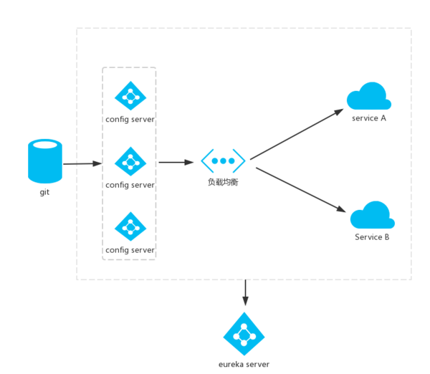

### 一、准备工作

继续使用上一篇文章的工程，创建一个eureka-server工程，用作服务中心。

其pom.xml:

<?xml version="1.0" encoding="UTF-8"?><project xmlns="http://maven.apache.org/POM/4.0.0" xmlns:xsi="http://www.w3.org/2001/XMLSchema-instance"

xsi:schemaLocation="http://maven.apache.org/POM/4.0.0 http://maven.apache.org/xsd/maven-4.0.0.xsd">

<modelVersion>4.0.0</modelVersion>

<groupId>com.forezp</groupId>

<artifactId>eureka-server</artifactId>

<version>0.0.1-SNAPSHOT</version>

<packaging>jar</packaging>

<name>eureka-server</name>

<description>Demo project for Spring Boot</description>

<parent>

<groupId>org.springframework.boot</groupId>

<artifactId>spring-boot-starter-parent</artifactId>

<version>1.5.2.RELEASE</version>

<relativePath/> <!-- lookup parent from repository -->

</parent>

<properties>

<project.build.sourceEncoding>UTF-8</project.build.sourceEncoding>

<project.reporting.outputEncoding>UTF-8</project.reporting.outputEncoding>

<java.version>1.8</java.version>

</properties>

<dependencies>

<dependency>

<groupId>org.springframework.cloud</groupId>

<artifactId>spring-cloud-starter-eureka-server</artifactId>

</dependency>

<dependency>

<groupId>org.springframework.boot</groupId>

<artifactId>spring-boot-starter-web</artifactId>

</dependency>

<dependency>

<groupId>org.springframework.boot</groupId>

<artifactId>spring-boot-starter-test</artifactId>

<scope>test</scope>

</dependency>

</dependencies>

<dependencyManagement>

<dependencies>

<dependency>

<groupId>org.springframework.cloud</groupId>

<artifactId>spring-cloud-dependencies</artifactId>

<version>Dalston.RC1</version>

<type>pom</type>

<scope>import</scope>

</dependency>

</dependencies>

</dependencyManagement>

<build>

<plugins>

<plugin>

<groupId>org.springframework.boot</groupId>

<artifactId>spring-boot-maven-plugin</artifactId>

</plugin>

</plugins>

</build>

<repositories>

<repository>

<id>spring-milestones</id>

<name>Spring Milestones</name>

<url>https://repo.spring.io/milestone</url>

<snapshots>

<enabled>false</enabled>

</snapshots>

</repository>

</repositories>

</project>

配置文件：

server:

port: 8889

eureka:

instance:

hostname: localhost

client:

registerWithEureka: false

fetchRegistry: false

serviceUrl:

defaultZone: http://${eureka.instance.hostname}:${server.port}/eureka/

入口类：

@EnableEurekaServer

@SpringBootApplication

public class EurekaServerApplication {

public static void main(String[] args) {

SpringApplication.run(EurekaServerApplication.class, args);

}

}

### 二、改造config-server

在其pom.xml文件下:

<dependencies>

<dependency>

<groupId>org.springframework.cloud</groupId>

<artifactId>spring-cloud-config-server</artifactId>

</dependency>

<dependency>

<groupId>org.springframework.boot</groupId>

<artifactId>spring-boot-starter-test</artifactId>

<scope>test</scope>

</dependency>

<dependency>

<groupId>org.springframework.cloud</groupId>

<artifactId>spring-cloud-starter-eureka</artifactId>

</dependency>

</dependencies>

配置文件,将其注册问服务：

spring.application.name=config-server

server.port=8888

spring.cloud.config.server.git.uri=https://github.com/forezp/SpringcloudConfig/

spring.cloud.config.server.git.searchPaths=respo

spring.cloud.config.label=master

spring.cloud.config.server.git.username= your username

spring.cloud.config.server.git.password= your password

eureka.client.serviceUrl.defaultZone=http://localhost:8889/eureka/

### 三、改造config-client

将其注册微 eureka服务，pom文件配置：

<dependency>

<groupId>org.springframework.cloud</groupId>

<artifactId>spring-cloud-starter-config</artifactId>

</dependency>

<dependency>

<groupId>org.springframework.boot</groupId>

<artifactId>spring-boot-starter-web</artifactId>

</dependency>

<dependency>

<groupId>org.springframework.cloud</groupId>

<artifactId>spring-cloud-starter-eureka</artifactId>

</dependency>

<dependency>

<groupId>org.springframework.boot</groupId>

<artifactId>spring-boot-starter-test</artifactId>

<scope>test</scope>

</dependency>

配置文件，bootstrap.properties

spring.application.name=config-client

spring.cloud.config.label=master

spring.cloud.config.profile=dev

#spring.cloud.config.uri= http://localhost:8888/

eureka.client.serviceUrl.defaultZone=http://localhost:8889/eureka/

spring.cloud.config.discovery.enabled=true

spring.cloud.config.discovery.serviceId=config-server

server.port=8881

* spring.cloud.config.discovery.enabled 是非从配置中心读取文件
* spring.cloud.config.discovery.serviceId 配置中心的servieId，即服务名

这时发现，在读取配置文件不再写ip地址，而是服务名，这时如果配置服务部署多份，通过负载均衡，从而高可用。

一次启动eureka-servr,config-server,config-client   
访问网址：[http://localhost:8889/](http://localhost:8889/" \t "http://blog.csdn.net/forezp/article/details/_blank)

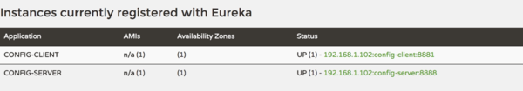

访问[http://localhost:8881/hi](http://localhost:8881/hi" \t "http://blog.csdn.net/forezp/article/details/_blank)，浏览器显示：

foo version 3

本文源码下载：   
[https://github.com/forezp/SpringCloudLearning/tree/master/chapter7](https://github.com/forezp/SpringCloudLearning/tree/master/chapter7" \t "http://blog.csdn.net/forezp/article/details/_blank)

### 四、参考资料

[spring\_cloud\_config](http://projects.spring.io/spring-cloud/spring-cloud.html" \l "_spring_cloud_config" \t "http://blog.csdn.net/forezp/article/details/_blank)